**New Hydroelectric Plant to Be Built for New York**

By [SAM ROBERTS](http://topics.nytimes.com/top/reference/timestopics/people/r/sam_roberts/index.html)SEPT. 15, 2014

Inside Photo

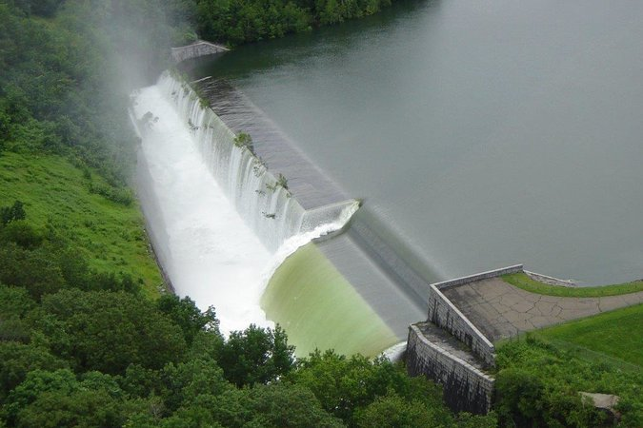

The city is planning to build a $72 million hydroelectric power plant at its Cannonsville Reservoir. Credit New York City Department of Environmental Protection.

It seems as natural as, well, water: Harness the energy potential of a 95-billion-gallon reservoir to run four turbines and generate electrical power cleanly and at a profit.

Having overcome potential hurdles ranging from drought-stricken rafters on the Delaware River to the endangered dwarf wedge mussel and northern wild monkshood, New York City is tapping the vast resources of its upstate reservoir system to commission a new hydroelectric plant.

The plant is projected to generate 14 megawatts of electric power, which the city would sell to the New York power grid. That is enough to provide electricity, on average, to 6,000 homes. By not using oil or coal to generate electricity, it is estimated that the plant would avoid the emission of 25,620 metric tons of greenhouse gases annually, or the equivalent of removing 5,400 cars from the road.

This would be the largest hydroelectric development in New York State in more than two decades and the first time power would be generated directly from a Delaware River branch.

The city is building the $72 million plant, which is expected to produce about $2 million a year in revenue from the sale of electricity. Construction is scheduled to begin in 2016.

“It’s not going to be a big cash cow, but it’s sustainable and we will make the money back in the long run,” said Emily Lloyd, the commissioner of the city’s Department of Environmental Protection.

Cannonsville is the newest and westernmost among 19 reservoirs and three lakes that collectively supply the city with water through an engineering marvel of interconnecting tunnels. Begun in 1842 as the Croton Aqueduct in what is now Westchester County, the system serves nine million customers in the state and can hold about 580 billion gallons of water — 95 percent of which is delivered by gravity.

Under an environmental resiliency plan initiated by former Mayor Michael R. Bloomberg and continued by the de Blasio administration, the city has been exploring both how to protect the vast reservoir system and how to extract energy from the one billion or so gallons of water that flow from it every day. The goal of the city’s sustainability and resiliency campaign, PlaNYC, is to reduce carbon emissions from fossil fuels and other sources 30 percent by 2030.

Two city power plants built in the 1950s generate power as water flows from one reservoir to another, as do two others, one owned by the state power authority and one privately. Both were built in the 1980s and pay a commission to the city on their sales of electricity.

The new plant at Cannonsville, in western Delaware County, about 120 miles northwest of the city, will generate power from water flowing from a spillway directly into the Delaware River. Under a 1954 United States Supreme Court ruling, the city can take up to 800 million gallons daily from the Delaware River as long as it ensures adequate flow downstream to sustain recreation and aquatic life in New Jersey and elsewhere.

The power plant required federal regulatory approval, including guarantees that the flow to the river would not be interrupted and that endangered species, such as the northern wild monkshood and the dwarf wedge mussel, which have been seen in the region but not at the project site, would not be affected.

Paul V. Rush, the city’s deputy commissioner for water supply, said other potential power-generating possibilities had been considered, such as generating power from water flowing through the vast tunnels connecting the reservoirs. But that was deemed impractical because it would impede the flow and would restrict the Environmental Protection Department’s flexibility to shift the supply among reservoirs, depending on water quality.

The department is identifying other energy-saving initiatives, including using methane captured from a sewage treatment plant in Brooklyn to power the plant and to produce natural gas for sale as well as generating electricity for a plant on Staten Island by installing solar panels.

The Cannonsville plant would be the system’s third biggest, after Neversink and East Delaware, both city-owned. Last winter’s severe weather led to higher electric rates so the two plants netted more than usual for the fiscal year that ended June 30, about $8.2 million from the wholesale power market.

The Cannonsville Reservoir, which was completed in 1964, is about 140 feet deep and was created by damming the West Branch of the Delaware River, displacing nearly a thousand residents. Water releases from the dam’s spillway are now timed scientifically, both to coincide with the weather and to maintain a basin downstream to absorb rainfall and reduce flooding.

“We have real-time weather forecasts, so we understand the risks of releasing water downstream and that it will not impact on a reliable supply for the City of New York,” Mr. Rush said.

Ms. Lloyd said other power plants also might be built and department engineers had also looked at capturing the flow from water and sewer mains in the city. But after investigating “space, technology and issues of economic feasibility at 30 sites,” she said, “this was the one that gave the most power.”